Kalypto: A Secure Steganography and Steganalysis Toolkit for Image-Based Data Hiding
Vishesh Dutt Sharma, Sourav Pandey, Ravikant Kumar Nirala
Sharda School of Engineering and Technology, Sharda University-Greater Noida, India
visheshduttsharmaofficial@gmail.com, souravp1312038@gmail.com, iitkgpravinirala@gmail.com
Abstract
The increasing demand for secure and covert communication in digital environments has led to the widespread adoption of steganography as a technique for concealing sensitive information within multimedia data. Unlike conventional cryptographic approaches that focus on protecting the content of communication, steganography aims to obscure the very existence of the message, thereby reducing the likelihood of interception and analysis. Image-based steganography has gained prominence due to the inherent redundancy and perceptual tolerance of digital images, which allow data to be embedded with minimal visual distortion. Among the various techniques available, Least Significant Bit (LSB), Adaptive LSB, and Pixel Value Differencing (PVD) have emerged as widely studied methods, each offering distinct advantages in terms of embedding capacity, imperceptibility, and computational complexity. However, the rapid advancement of steganalysis techniques and increasing concerns related to data security have exposed limitations in traditional approaches, particularly in their vulnerability to statistical detection and lack of adaptability across diverse image characteristics. While recent research has explored improved embedding strategies and hybrid models, there remains a need for a systematic and fair comparative evaluation of these techniques under consistent experimental conditions. This work presents a structured comparative analysis of LSB, Adaptive LSB, and PVD techniques using a unified evaluation framework that assesses their performance based on image quality, embedding efficiency, and robustness. The proposed approach enables a comprehensive understanding of the trade-offs associated with each method and provides insights into their suitability for real-world cybersecurity applications, including secure communication, digital forensics, and data protection systems.

Keywords: Steganography, Secure Communication, Image-Based Steganography, LSB, Adaptive LSB, PVD, Steganalysis
- Introduction
The rapid evolution of digital communication technologies has significantly transformed how information is transmitted and secured across networks. Steganography, which involves hiding secret data within digital media such as images, has emerged as a crucial technique for enabling covert communication without revealing the presence of sensitive information. Unlike cryptographic methods that focus on encrypting content, steganography conceals the existence of the message itself, thereby reducing the likelihood of detection. Image-based steganography techniques, particularly those operating in the spatial domain, have gained widespread attention due to their simplicity and effectiveness. Among these, Least Significant Bit (LSB), Adaptive LSB, and Pixel Value Differencing (PVD) techniques are widely used for embedding data within images while maintaining visual quality [4], [6]. However, these methods introduce varying levels of distortion and exhibit different vulnerabilities to statistical and visual steganalysis attacks, raising concerns regarding their reliability in security-critical applications [3], [5]. The increasing sophistication of steganalysis techniques and the growing demand for secure data hiding mechanisms have further highlighted the need for robust and adaptive embedding strategies
Evaluating the effectiveness of steganographic techniques remains challenging due to trade-offs between embedding capacity, imperceptibility, and robustness. Traditional LSB methods offer high payload capacity but suffer from predictable embedding patterns, making them susceptible to detection. In contrast, Adaptive LSB techniques attempt to improve imperceptibility by selectively embedding data in complex image regions, while PVD methods exploit pixel intensity variations to achieve a balance between capacity and visual quality. Despite these advancements, the lack of a unified and consistent evaluation framework makes it difficult to accurately compare these techniques under identical conditions [3], [9]. Additionally, variations in image characteristics and payload sizes further complicate performance assessment, necessitating a structured comparative approach.

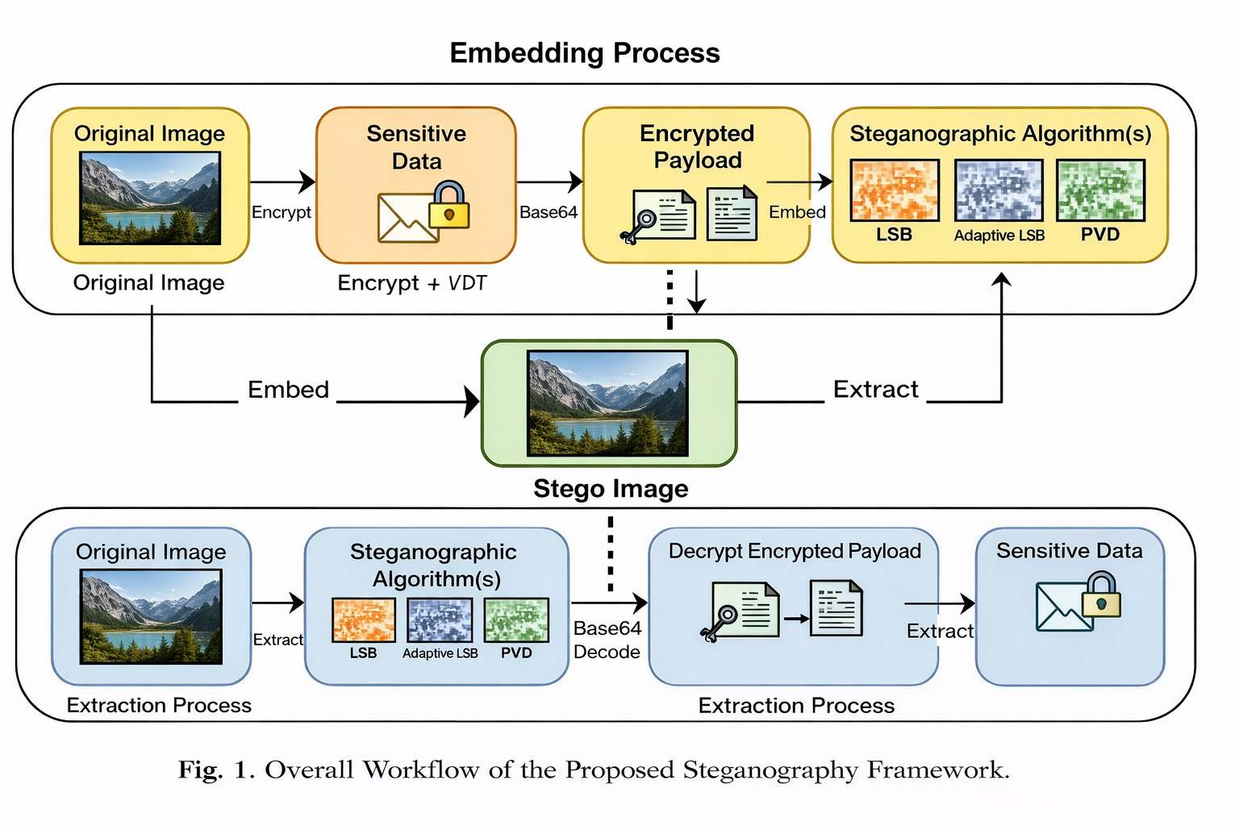
Fig. 1 Overall Workflow of the Proposed Steganography Framework.
This paper presents a comprehensive comparative analysis of LSB, Adaptive LSB, and PVD steganography techniques using a unified evaluation framework. The study aims to systematically assess the performance of each method in terms of image quality, embedding efficiency, and robustness under consistent experimental conditions. The key contributions of this work are:
- Designing a unified comparative framework that evaluates LSB, Adaptive LSB, and PVD techniques using standardized metrics such as PSNR, MSE, and embedding capacity.
- Conducting an empirical analysis of the three techniques under identical experimental conditions to ensure fair and reliable performance comparison.
- Analyzing the strengths and limitations of each method to determine their suitability for real-world applications such as secure communication, digital forensics, and data protection systems.
- Related work
The study of image steganography has been an important research area due to the increasing demand for secure and covert communication. Early research primarily focused on spatial domain techniques such as Least Significant Bit (LSB) substitution, where secret data is embedded by modifying the least significant bits of pixel values. These methods offered high embedding capacity and low computational complexity but were found to be vulnerable to statistical and visual steganalysis due to predictable embedding patterns. Chan and Cheng [4] proposed an improved LSB substitution method to reduce distortion, while Fridrich et al. [5] highlighted the detectability limitations of LSB-based approaches.
Subsequent research introduced adaptive embedding strategies and Pixel Value Differencing (PVD) techniques to address these limitations. Adaptive LSB methods dynamically select embedding regions based on image characteristics such as edges and textures, improving imperceptibility and resistance to detection. Yang et al. [8] proposed an adaptive approach that adjusts embedding capacity according to local pixel variations, while Tseng and Leng [7] demonstrated improved visual quality through edge-based embedding. In parallel, Wu and Tsai [6] introduced the PVD technique, which utilizes differences between adjacent pixel values to balance embedding capacity and image quality. Hybrid approaches combining PVD with LSB have further enhanced performance in terms of security and efficiency [9]. Comparative studies have evaluated these techniques using metrics such as PSNR and MSE, highlighting trade-offs between imperceptibility and payload capacity [10]. However, challenges such as vulnerability to advanced steganalysis and the lack of standardized evaluation frameworks remain unresolved.
This work presents a structured comparative analysis of LSB, Adaptive LSB, and PVD techniques under a unified experimental framework to provide a consistent and practical evaluation of their performance in real-world scenarios.

- Proposed Methodology
The framework presents an image-based steganography system that leverages spatial-domain techniques to enable secure and covert data embedding within digital images. It consists of three main parts: Data Preparation and Encryption, Data Embedding and Extraction, and Pipeline Execution.
  - System Features
The system includes features that enhance the reliability and security of data hiding. It supports multiple spatial-domain techniques including Least Significant Bit (LSB), Adaptive LSB, and Pixel Value Differencing (PVD), implemented in a modular architecture. An integrated encryption layer is used to secure payload data using AES, ChaCha20, XOR, or Fernet algorithms, with both manual and automatic selection supported. The system allows file-based payload input from formats such as .txt, .csv, .json, .pdf, and .docx through text extraction. A base64 encoding layer ensures safe data handling during embedding, while a fixed-length header mechanism enables accurate payload reconstruction during extraction. The system operates through a command-line interface, ensuring efficient execution and practical usability.
  - Proposed Model
The proposed model comprises the following steps:
Data Preparation: Payload data $D=\left\{d_{1},d_{2}, ...,d_{k}\right\}$ is extracted from input files and encoded using base64.
Encryption: The encoded data is encrypted using a selected algorithm, producing $D_{e}$​.
Image Processing: The cover image $I=\left\{p_{1},p_{2}, ...,p_{n}\right\}$is loaded and prepared for embedding.
Data Embedding: The encrypted payload is embedded into pixel values using LSB, Adaptive LSB, or PVD, resulting in a stego-image $I_{s}$.
Data Extraction: The embedded data is retrieved from $I_{s}$​, decoded, and decrypted to reconstruct the original payload.
The overall workflow represents a complete encoding and decoding pipeline.
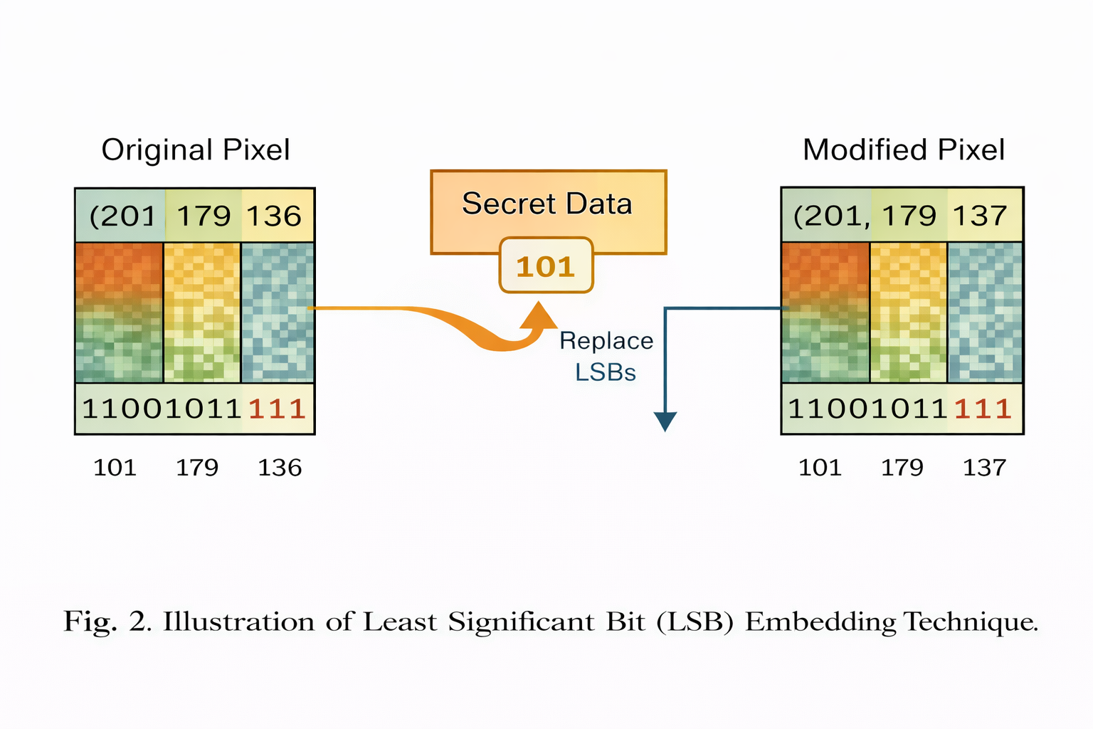
Fig.2 Illustration of Least Significant Bit (LSB) Embedding Technique.

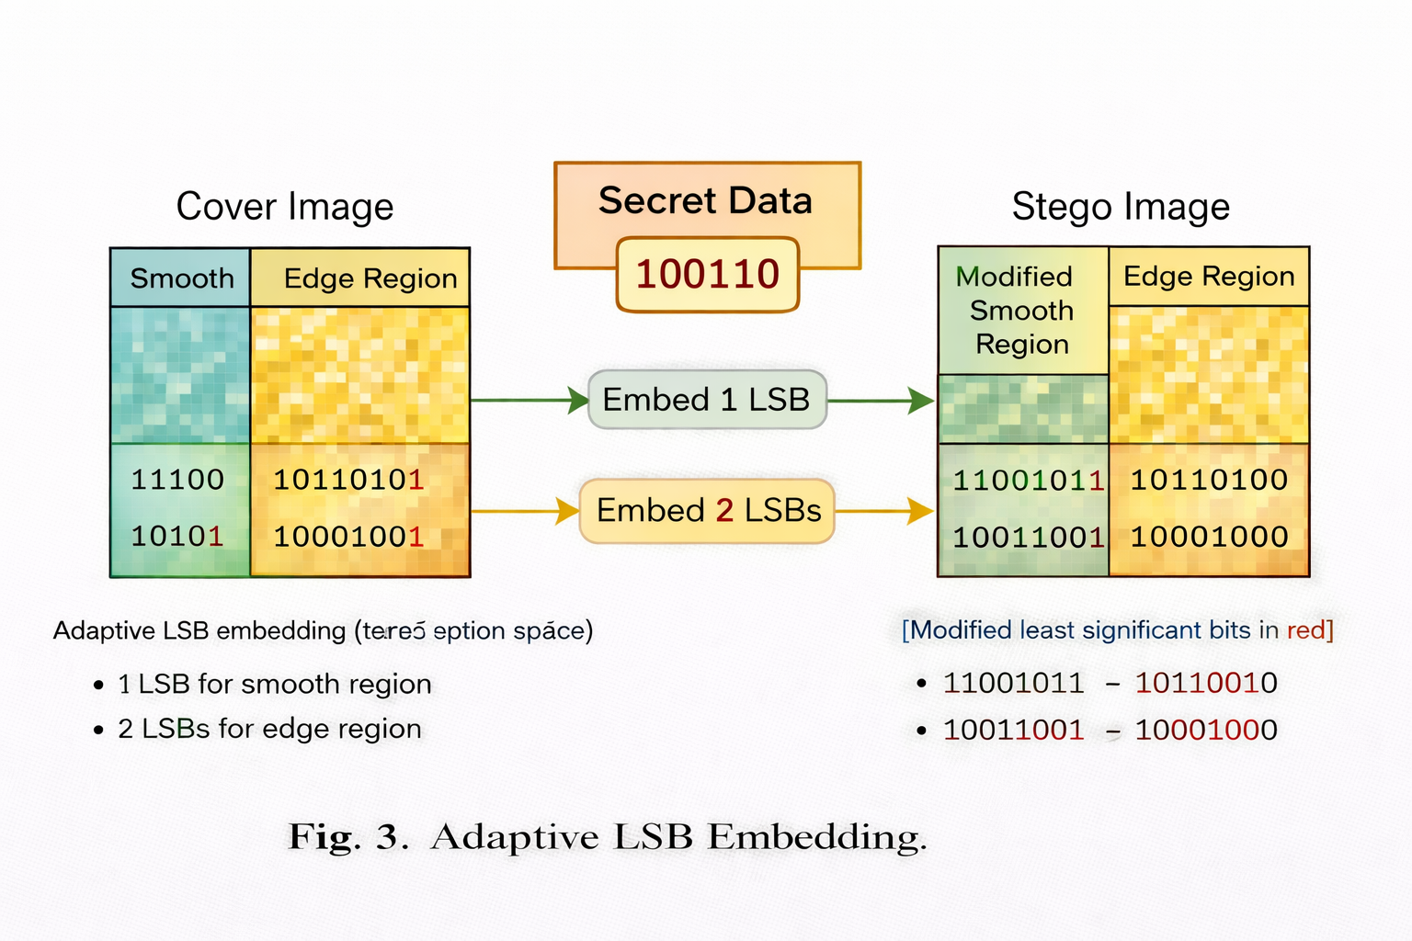
Fig.3 Adaptive LSB Embedding.
  - Experimental Workflow
The experimental workflow consists of structured stages to validate system functionality and reliability. The process begins with selecting input images and payload files supported by the system. Payload data is extracted, converted into textual format, and encoded using base64, while the image is prepared for pixel-level operations.
Embedding: The encoded and encrypted payload is embedded into the image using the selected spatial-domain technique, generating a stego-image with minimal visual distortion.
Extraction: The system retrieves embedded data from the stego-image using the corresponding decoding process, followed by base64 decoding and decryption to recover the original content.
Validation: The extracted data is compared with the original payload to verify correctness and integrity. The fixed-length header ensures accurate payload size and reconstruction.
This workflow ensures consistent execution of steganographic operations and demonstrates the system’s ability to securely embed and retrieve data in practical scenarios and compatibility across different payload types by standardizing preprocessing and encoding steps, allowing uniform handling of diverse input formats. This consistency improves reliability and enables repeatable execution of embedding and extraction processes across multiple experimental runs.
- Experimental result analysis
The proposed image-based steganography framework was evaluated using a set of standard digital images with varying resolutions and texture characteristics to ensure diverse testing conditions. The evaluation focused on assessing the system’s ability to securely embed and accurately extract payload data while maintaining visual quality. Multiple payload types, including text and file-based inputs, were tested to validate the robustness of the encoding and decoding pipeline. The performance of the system was analysed based on image distortion, embedding reliability, and data integrity across different steganographic techniques. In addition to visual quality, the evaluation considered the effectiveness of the encryption layer integrated within the pipeline. The system’s ability to securely transform and reconstruct payload data using different encryption algorithms was examined. The processing workflow was also analysed in terms of execution consistency and reliability across multiple runs. These assessments confirm that the framework provides a practical and secure solution for covert data embedding while maintaining efficiency and usability in real-world scenarios.
  - Evaluation Parameter
To evaluate the performance and reliability of the proposed steganography system, the following metrics are used:
Mean Squared Error$\left(MSE\right)$: Represents the average squared difference between the original image $I$ and stego-image $I_{s}$.
$$MSE=\frac{1}{M}\sum_{i=1}^{M}{\sum_{j=1}^{N}{{\left[I\left(i,j\right)-I_{s}\left(i,j\right)\right]}^{2}}}$$
Peek Signal-to-Noise Ratio $\left(PSNR\right)$: Measures image quality after embedding.
$$PSNR=10∙\log_{10}\left(\frac{{MAX}^{2}}{MSE}\right)$$
Embedding Capacity (C): Represents the amount of data embedded relative to image size.
$$C=\frac{Total Embedded Bits}{Total Pixels}$$
Extraction Accuracy $\left(A\right)$: Measures correctness of retrieved payload.
$$A=\frac{Correcttly Extracted Bits}{Total Embedded Bits}$$
Encryption Transformation: The payload $D$ is transformed into encrypted data $D_{e}$ using a selected algorithm:
$$D_{e}=E_{k}\left(D\right)$$
Decryption: The original payload is recovered using the corresponding key $k$:

$$D=D_{k}\left(D_{e}\right)$$

Base64 Encoding Overhead $\left(O\right)$:

$$ρ=\frac{Encoded Size - Original Size}{Original Size}$$
These metrics collectively evaluate image quality, embedding efficiency, data integrity, and encryption reliability, providing a comprehensive assessment of the proposed system.

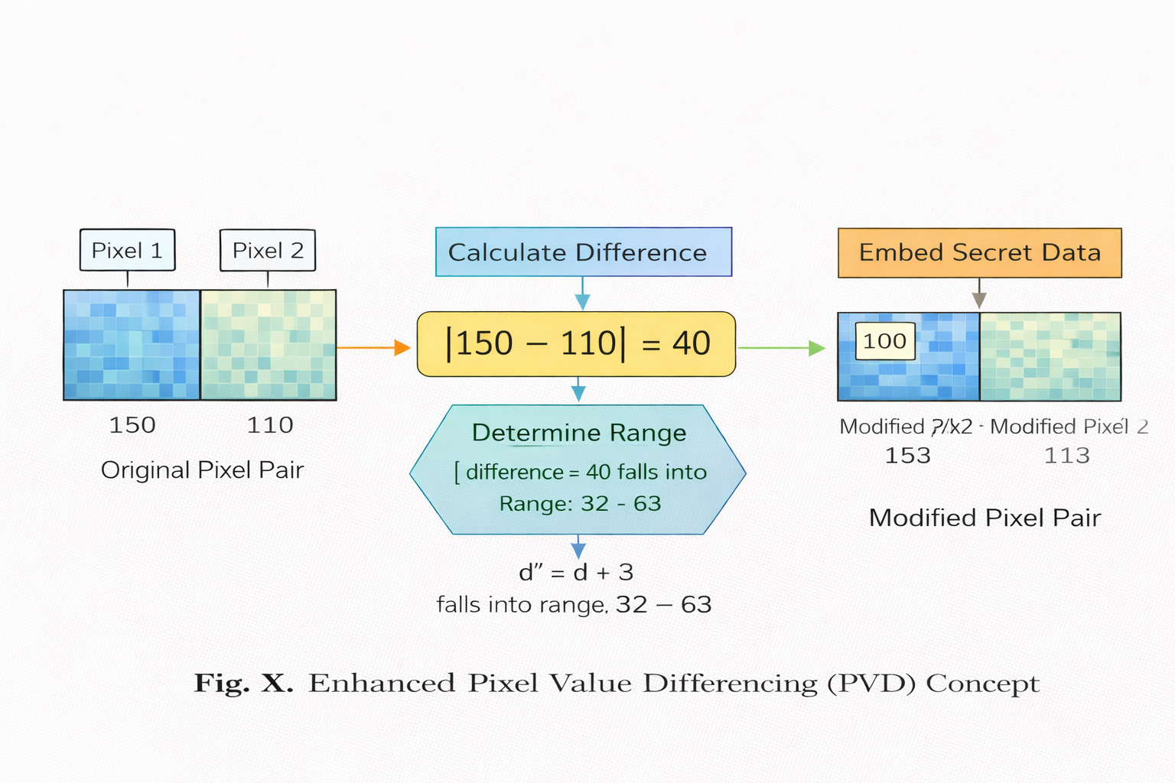Fig.4 Pixel Value Differencing (PVD) Concept.

Table 1. Evaluation Parameter

Metric | Description | Formula
MSE | Image distortion | $$MSE=\frac{1}{M}\sum_{i=1}^{M}{\sum_{j=1}^{N}{{\left[I\left(i,j\right)-I_{s}\left(i,j\right)\right]}^{2}}}$$
PSNR | Image quality | $$PSNR=10∙\log_{10}\left(\frac{{MAX}^{2}}{MSE}\right)$$
Capacity (C) | Bits per pixel | $$C=\frac{B}{P}$$
Accuracy (A) | Extraction correctness | $$A=\frac{B_{e}}{B}$$
Encryption | Data encoding | $$D_{e}=E_{k}\left(D\right)$$
Decryption | Data recovery | $$D=D_{k}\left(D_{e}\right)$$
Overhead (O) | Size increase | $$ρ=\frac{S_{e}-S}{S}$$

This template, modified in MS Word 2007 and saved as a “Word 97-2003 Document” for the PC, provides authors with most of the formatting specifications needed for preparing electronic versions of their papers.

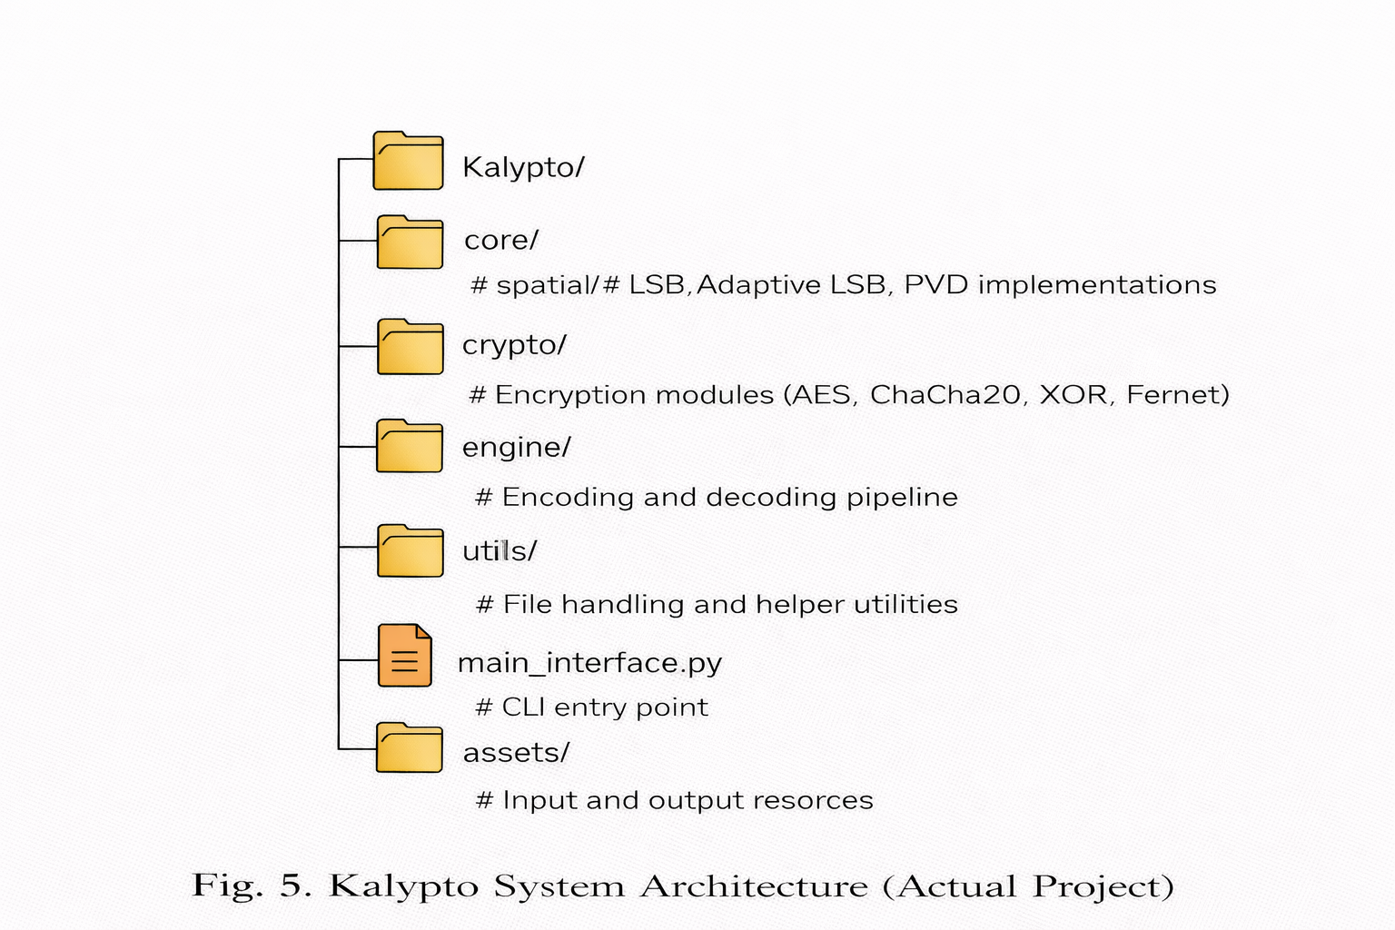
Fig.5 Kalypto System Architecture (Actual Project).
  - Comparative analysis of proposed model
The comparative analysis between LSB, Adaptive LSB, and PVD techniques is summarized in Table 2. The results demonstrate that while LSB provides higher embedding capacity and faster execution, it suffers from lower imperceptibility and increased vulnerability to detection due to its sequential embedding nature. Adaptive LSB improves upon this by selectively embedding data in complex image regions, resulting in better visual quality and reduced statistical detectability without significantly increasing computational cost. PVD further enhances imperceptibility by utilizing pixel intensity differences to dynamically adjust embedding capacity, achieving a balanced trade-off between image quality and payload size.
Additionally, the performance of all three techniques remained consistent across different image types, indicating reliability of the proposed framework. The inclusion of encryption and structured payload handling further strengthens data security without affecting embedding performance. Although Adaptive LSB and PVD introduce slightly higher computational overhead compared to basic LSB, the increase is minimal and does not impact practical usability. Overall, the findings indicate that Adaptive LSB and PVD offer superior robustness and imperceptibility, while LSB remains suitable for scenarios prioritizing simplicity and speed, making the framework effective for diverse real-world applications.

Table 2. Comparative analysis
Metric | LSB | Adaptive LSB | PVD
Imperceptibility (PSNR) | Moderate | High | Very High
MSE | Higher | Lower | Lowest
Embedding Capacity | High | Moderate-High | Moderate
Extraction Accuracy | High | High | High
Security (Detectability) | Low | Moderate | High
Computational Complexity | Low | Moderate | Moderate
Execution Time | Fast | Moderate | Moderate
Robustness | Low | Moderate | High
Flexibility | Low | Moderate | High
- Conclusion and Future Scope
The steganography framework proposed in this research effectively integrates multiple spatial-domain techniques, including LSB, Adaptive LSB, and PVD, along with encryption mechanisms to provide a reliable solution for secure and covert data communication. Experimental analysis demonstrates that while LSB offers simplicity and high embedding capacity, Adaptive LSB and PVD significantly improve imperceptibility and resistance to detection by leveraging image characteristics. The system successfully maintains data integrity through its encoding and decoding pipeline, supported by base64-based transport and a fixed-length header mechanism for accurate payload reconstruction. Furthermore, the integration of multiple encryption algorithms enhances confidentiality without compromising embedding performance, ensuring that extracted data remains secure. The modular architecture and command-line interface contribute to efficient execution and practical usability across different scenarios. Although advanced techniques introduce moderate computational overhead, the system remains suitable for real-world applications such as secure communication and digital forensics. This work highlights the importance of balancing embedding capacity, image quality, and security in steganographic systems. Future work will focus on implementing true binary-safe embedding to eliminate base64 overhead, extending support for larger and more complex file types, and integrating transform-domain techniques such as DCT and DWT for improved robustness. Additionally, incorporating advanced steganalysis metrics and optimizing performance for resource-constrained environments will further enhance the system’s scalability and applicability in diverse cybersecurity contexts.

References

[1] N. Provos and P. Honeyman, “Hide and seek: An introduction to steganography,” IEEE Security & Privacy, vol. 1, no. 3, pp. 32–44, 2003.
[2] J. Fridrich, “Steganography in digital media: Principles, algorithms, and applications,” Cambridge University Press, 2009.
[3] A. Cheddad, J. Condell, K. Curran, and P. Mc Kevitt, “Digital image steganography: Survey and analysis of current methods,” Signal Processing, vol. 90, no. 3, pp. 727–752, 2010.
[4] C.-K. Chan and L. M. Cheng, “Hiding data in images by simple LSB substitution,” Pattern Recognition, vol. 37, no. 3, pp. 469–474, 2004.
[5] J. Fridrich, M. Goljan, and R. Du, “Detecting LSB steganography in color and grayscale images,” IEEE Multimedia, vol. 8, no. 4, pp. 22–28, 2001.
[6] D. C. Wu and W.-H. Tsai, “A steganographic method for images by pixel-value differencing,” Pattern Recognition Letters, vol. 24, no. 9–10, pp. 1613–1626, 2003.
[7] H.-W. Tseng and Y.-P. Leng, “A steganographic method based on pixel-value differencing and LSB substitution,” Pattern Recognition Letters, vol. 25, no. 5, pp. 585–594, 2004.
[8] C.-H. Yang, C.-Y. Weng, S.-J. Wang, and H.-M. Sun, “Adaptive data hiding in edge areas of images with spatial LSB domain systems,” IEEE Transactions on Information Forensics and Security, vol. 3, no. 3, pp. 488–497, 2008.
[9] X. Liao, Q. Wen, and J. Zhang, “A steganographic method for digital images with four-pixel differencing and modified LSB substitution,” Journal of Visual Communication and Image Representation, vol. 22, no. 1, pp. 1–8, 2011.
[10] S. Katzenbeisser and F. A. P. Petitcolas, “Information hiding techniques for steganography and digital watermarking,” Artech House, 2000.
[11] R. Chandramouli and N. Memon, “Analysis of LSB based image steganography techniques,” IEEE International Conference on Image Processing, pp. 1019–1022, 2001.
[12] K. Curran and K. Bailey, “An evaluation of image based steganography methods,” International Journal of Digital Evidence, vol. 2, no. 2, pp. 1–8, 2003.
[13] A. Westfeld and A. Pfitzmann, “Attacks on steganographic systems,” International Workshop on Information Hiding, pp. 61–76, 1999.
[14] J. Mielikäinen, “LSB matching revisited,” IEEE Signal Processing Letters, vol. 13, no. 5, pp. 285–287, 2006.
[15] T. Sharp, “An implementation of key-based digital signal steganography,” Information Hiding Workshop, pp. 13–26, 2001.
[16] W. Stallings, “Cryptography and network security: Principles and practice,” 7th ed., Pearson, 2017.
[17] National Institute of Standards and Technology (NIST), “Advanced Encryption Standard (AES),” FIPS PUB 197, 2001.
[18] D. J. Bernstein, “ChaCha, a variant of Salsa20,” Workshop Record of SASC, 2008.
[19] M. Naor and B. Pinkas, “Efficient oblivious transfer protocols,” SIAM Journal on Computing, vol. 35, no. 1, pp. 45–69, 2005.
[20] R. Gonzalez and R. Woods, “Digital Image Processing,” 4th ed., Pearson, 2018.

